Joel Lantigua

Linux administrator

Using Grep command

9/29/22

Grep

When I was doing the grep assignment, I had to download a data file from Blackboard on my host computer. I first made a folder that I was going to share, naming it **Sharetoserver**. I then added the data file that I downloaded to the folder. Next, I needed to open the command prompt so that I can send the folder to my Ubuntu server using the command **scp -r Sharetoserver joel@192.168.241.136:** As you can see below the data file named **GrepLab (2)** was successfully sent.

Next, I switched over to my ubuntu server and use the command **ls** to check if the **Sharetoserver** folder is there. Once I see that the folder is there, I use the command **cd Sharetoserver** to change into the directory. Now if I use the command **ls** I should be able to see the **GrepLab (2)** data file.

Question 1, print all line containing the string Lane? For this we used the command **grep Lane GrepLab\ \(2\)**. **GrepLab\ \(2\)** is the name of the file, since I saved the file as **GrepLab (2)** Ubuntu prints it out like that. This command searches for everything that has the word Lane in the file.

Question 2, Print all lines where the persons first name starts with H? For this search we are going to use the command **grep ‘^H’ GrepLab\ \(2\).** This comandis going to print everyone that has **H** as the first letting in their name. we are going to do the same as the previous question but instead of just an H we are going to add the carrot infront of it **“^H”**. Adding the carrot means the beginning of the search your looking for.

Question 3, Print all lines ending in 000? For this question we are going to use the comand **grep -i 000$ GrepLab\ \(2\).** For this command we are going to use **-i** which is for case insensitvie searches followed by the number you are looking for in this case it’s **000** and we use the dollar sign after it because it repersents the end of a line. **“000$”**

Question 4, Print all lines that don’t contain 408?: for this question we are goin to use the command **grep -v 408 GrepLab\ \(2\)**. In this command **-v** returns all lines which don’t match the pattern you inserted, In this case we inserted **408**. As you can see in the imaged below.

Question 5, Print all Lines where birthdays are in the year 1935?: For this question we are going to use the command **grep -E ‘[0-12]\/[0-31]\/35+’ GrepLab\ \(2\)**. In this command -E is to use extended regex. Next we are going to use brackets and in the brackets we are goin to put **[0-12]** this represent a the months in digit. Next I used **\/ to repersent the dash**. I then used the brackets again and put **[0-31]** to represent the days of the month, fowlled by another dash then **35+** cause we only want birthdays in year 35.

Question 6, Print all lines where the phone number is an area code that starts with 8? for this question we are going the command **grep -E ‘(8) [0-9] {2}-[0-9] {3}-[0-9] {4}: ’ GrepLab\ \(2\).** This command is going to be simlier to the previous one. We are goin to start with **(8)** because that’s the number we want at the beginning, then we are goin to use the box brackets to represent the digits of a phone number **[0-9].** followed by curly brakets and the amount of digits needed in that section of the phone number. Since we want all phone numbers that start with **(8)** in the curly brackets for the first section of the phone number you would just need a 2 in the curly brackets, **(8)** **[0-9] {2}.** For the next sextion you would need 3 digits and the last you would need 4.

Question 7, Print all lines containing an uppercase letter, followed by 4 lowercase letters , a space and one uppercase letter? For this question we are going to use the command **grep ‘ [A-Z] [a-z]\{4\}, [A-Z] ’ GrepLab\ \(2\).**  The **[A-Z]** means that the first letter has to be upercase, then  **[a-z]\{4\}** means anything after the upercase letter has to be 4 lowercase letters.Next I used a “**,”** to indicate a space followed by **[A-Z]** to represent that one uppercase letter.

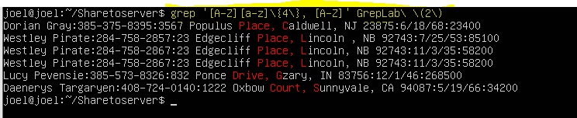

Question 8, Print lines where the address begins with a 2 or 3 digit number? For this question we used the command **grep -P ‘ :\d{2,3} [A-Z] ’ GrepLab\ \(2\).** In this command I use the **\d** to represent a digit followed by curly brackets with 2 and 3 in them **{2,3}**. The 2 and 3 are for the addresses that have 2 digits in them or 3 digits. Then I used [A-Z] to represent the beginning letter of the address.

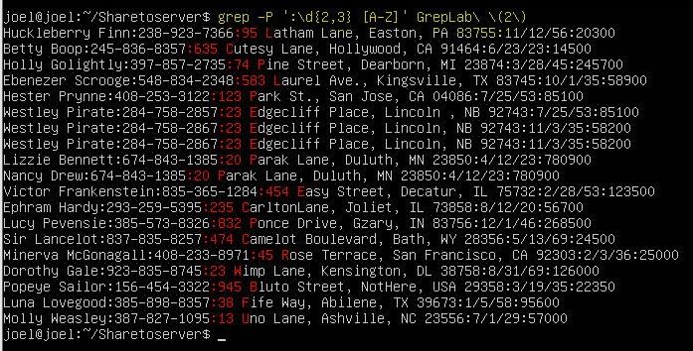

Question 9, Print lines where the pereson lives in MASS or ILLINOIS?: For this question we are going to use the command **grep -E ‘MA|IL’ GrepLab\ \(2\).** For this command we are going to use the -E followed the abriviation of the first states you are looking for. Rember to use **“|”** in between the two states your looking for. The “|” is used to split the seach between MA and IL alowing you to look for both at the same time.

Question 10, Print lines containing the addresses that aren’t on a street? For this question we are going to use the command **grep -v St GrepLab\ \(2\) | grep -v Street GrepLab\ \(2\).** It’s like question 4 but instead of the digit we are going to use the abbreviation for street which is **St.** Then I used “**|**” to add another sed command which was **grep -v Street GrepLab\ \(2\)** to delete any address that have the word **Street** in it.

Work Cited

<https://quickref.me/grep>

<https://staff.washington.edu/weller/grep.html>

<https://www.pair.com/support/kb/paircloud-grep/>